Quick Cart Sales & Operations Analysis
End-to-End Data Analytics Project

1. Project Overview
Quick Cart is an e-commerce grocery platform that handles orders across multiple cities. To improve operational performance and customer experience, the company wants to analyse its order data to identify sales trends, delivery efficiency, inventory risks, and payment behaviour.
This project performs an end-to-end data analysis using:
- Python → Data Cleaning
- MySQL → Data Analysis
- Power BI → Data Visualization
The objective is to convert raw order data into business insights that support strategic decision-making.

2. Business Objectives
Quick Cart aims to analyse order data to:
- Identify top-performing product categories
- Track sales performance by city
- Evaluate delivery efficiency
- Monitor inventory risks
- Understand customer satisfaction
- Analyse payment method trends

3. Dataset Description
The dataset contains 1,200 order records from Quick Cart operations.
Important columns include:
- Order ID
- Product Name
- Product Category
- City
- Order Date
- Delivery Partner
- Delivery Time
- Customer Rating
- Payment Method
- Stock Status
- Revenue
These fields allow analysis of sales, operations, and customer behaviour.

4. Data Cleaning Using Python
Python was used to clean and prepare the dataset before analysis.
Key cleaning steps included:
- Removing duplicate records
- Handling missing values
- Standardizing column names
- Converting data types
- Creating new columns such as:
  - Order Year
  - Order Month
  - Day
  - Delivery Speed
  - Stock Status
Python libraries used:
- Pandas
- NumPy
The cleaned dataset was exported as a CSV file and then imported into MySQL.

5. Data Storage and Analysis Using MySQL
The cleaned dataset was imported into a MySQL database to perform structured queries.
SQL queries were used to:
- Calculate revenue and order metrics
- Identify top categories and cities
- Evaluate delivery partner performance
- Analyse payment trends
- Monitor stock availability

6. SQL Analysis Results

Overall Business Performance
Total Revenue
503,233
Total Orders
1,200

Revenue by Product Category
Category |  |  |  |  |  | Revenue
Bakery |  |  |  |  |  | 90,664
Fruits |  |  |  |  |  | 87,343
Snacks |  |  |  |  |  | 85,740
Beverages |  |  |  |  |  | 84,968
Frozen |  |  |  |  |  | 82,096
Dairy |  |  |  |  |  | 72,422
Insight
Bakery products generate the highest revenue, making them the top-performing category.

Sales by City
City |  |  |  |  |  |  |  |  |  |  | Revenue
Delhi |  |  |  |  |  |  |  |  |  |  | 94,077
Pune |  |  |  |  |  |  |  |  |  |  | 90,839
Mumbai |  |  |  |  |  |  |  |  |  |  | 84,543
Bangalore |  |  |  |  |  |  |  |  |  |  | 78,966
Hyderabad |  |  |  |  |  |  |  |  |  |  | 78,136
Chennai |  |  |  |  |  |  |  |  |  |  | 76,672
Insight
Delhi contributes the most revenue, indicating strong customer demand in this region.

Delivery Partner Performance

Average Delivery Time
Fastest delivery partner:
Vikram (27.96 minutes)
Slowest delivery partner:
Arjun (31.48 minutes)

Customer Ratings by Delivery Partner
Highest rating:
Karthik (4.05)

Payment Method Usage
Payment Method |  |  |  |  |  |  |  |  |  |  |  | Orders
Wallet |  |  |  |  |  |  |  |  |  |  |  | 308
COD |  |  |  |  |  |  |  |  |  |  |  | 300
Card |  |  |  |  |  |  |  |  |  |  |  | 299
UPI |  |  |  |  |  |  |  |  |  |  |  | 293
Insight
Customers use all payment methods almost equally, with wallet payments slightly higher.

Inventory Status
Stock Status |  |  |  |  |  |  |  |  | Orders |  |  |  |  |  |  |  | Revenue
In Stock |  |  |  |  |  |  |  |  | 782 |  |  |  |  |  |  |  | 330,537
Low Stock |  |  |  |  |  |  |  |  | 418 |  |  |  |  |  |  |  | 172,696
Insight
A significant portion of orders comes from low-stock products, indicating a potential risk of inventory shortages.

7. Power BI Dashboard
The interactive dashboard titled:

Quick Cart Sales & Operations Dashboard
Was created using Power BI to visualize key business insights.
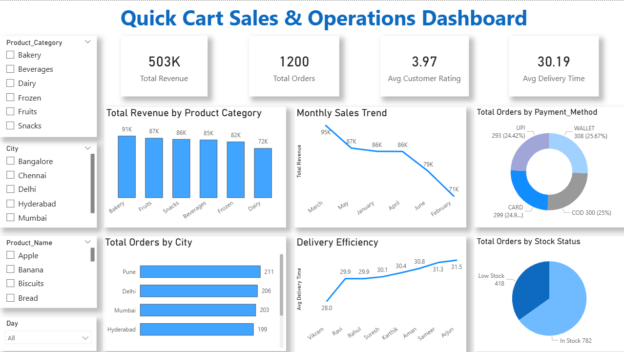

KPI Cards
The dashboard includes key performance indicators:
- Total Revenue: 503K
- Total Orders: 1200
- Average Customer Rating: 3.97
- Average Delivery Time: 30.19 minutes

Dashboard Visualizations

Revenue by Product Category
A bar chart shows revenue distribution across categories.
Insight:
Bakery and Fruits contribute the highest sales.

Monthly Sales Trend
A line chart shows how revenue changes across months.
Insight:
Sales fluctuate across months, indicating seasonal purchasing patterns.

Orders by Payment Method
A donut chart displays the share of payment methods.
Insight:
Wallet payments are the most frequently used.

Orders by City
A horizontal bar chart highlights cities with the highest order volume.
Insight:
Pune, Delhi, and Mumbai generate the most orders.

Delivery Efficiency
A line chart compares delivery time across partners.
Insight:
Vikram delivers the fastest while Arjun takes the longest time.

Orders by Stock Status
A pie chart shows the distribution of orders between in-stock and low-stock products.
Insight:
Low-stock items still generate a considerable number of orders.

8. Key Business Insights
- Bakery products generate the highest revenue among all categories.
- Delhi and Pune are the strongest markets for Quick Cart.
- Vikram provides the fastest delivery service.
- Karthik receives the highest customer ratings.
- Payment usage is evenly distributed across Wallet, COD, Card, and UPI.
- 418 orders come from low-stock products, indicating inventory risk.

9. Business Recommendations

Improve Inventory Planning
Low-stock products generate significant orders. Quick Cart should improve stock forecasting to prevent product shortages.

Focus on High-Demand Cities
Cities like Delhi and Pune should receive more marketing and supply attention to maximize revenue.

Optimize Delivery Operations
Analyse the performance of faster delivery partners to improve overall delivery efficiency.

Encourage Digital Payments
Promote wallet and UPI payments through offers or cashback programs.

10. Conclusion
This project demonstrates a complete end-to-end data analytics workflow, transforming raw order data into actionable business insights.
Using Python for data cleaning, MySQL for analysis, and Power BI for visualization, the project provides valuable insights into sales performance, logistics efficiency, payment behaviour, and inventory management.
These insights can help Quick Cart make data-driven decisions to improve operations and increase revenue.

